Make sure to pick the right version of the Gemma board in the IDE! If you're using the Adafruit Gemma it won't program correctly when selecting the Arduino Gemma option and vice versa! Carefully read the instructions below to pick the right board.

Adafruit Gemma (Black Gemma)

If you're using the **Adafruit Gemma** (with a **black** PCB board) select the **Adafruit Gemma 8MHz**board from the **Tools->Board**menu.

[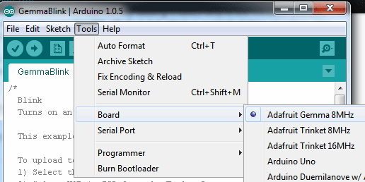](https://learn.adafruit.com/assets/10921)`

Then, select **USBtinyISP** from the **Tools->Programmer** sub-menu

[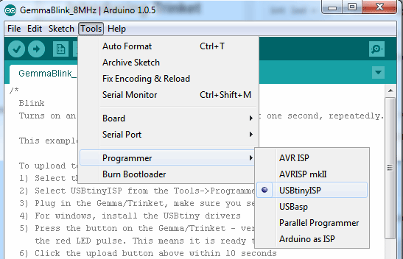](https://learn.adafruit.com/assets/10922)

Arduino Gemma (Teal Gemma)

However if you're using the newer **Arduino Gemma** (with a**teal** PCB board) select the Arduino Gemma board from the**Tools->Boards** menu.

[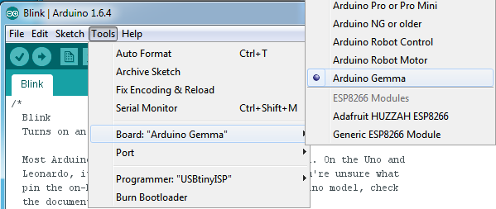](https://learn.adafruit.com/assets/25360)

Then select **Arduino Gemma** as the Programmer type

[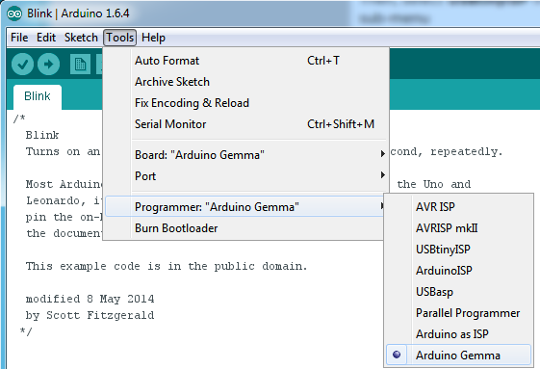](https://learn.adafruit.com/assets/25361)

Get Into Bootloader Mode

Plug in the Gemma, make sure you see the green LED lit (power good) and the red LED pulsing. Press the button if the red LED is not pulsing, to get into bootloader mode.   
  
Click the**Upload** button (or select **File->Upload**)

[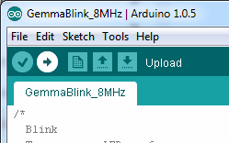](https://learn.adafruit.com/assets/10923)

If everything goes smoothly you should see the following (no red error messages) and of course, the red LED on the Gemma will blink on/off once a second

[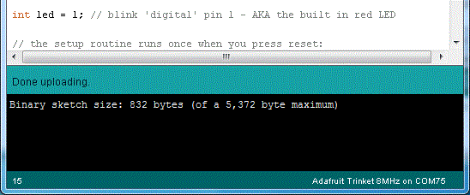](https://learn.adafruit.com/assets/25571)

Something Went Wrong!

If you get the error message avrdude: Error: Could not find USBtiny device (0x1781/0xc9f)

That means the bootloader wasn't active. Make sure to press the button on the Gemma to activate the bootloader *before*clicking the Upload button.

[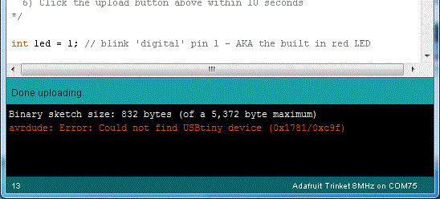](https://learn.adafruit.com/assets/25572)

If you get a lot of red text, errors and also a warning about Verification Failed

Check that you updated the avrdude.conf file above - if you don't update the description of the Attiny85 in the configure file by replacing it, the IDE wont know to be patient with the Gemma bootloader and will have many upload errors

[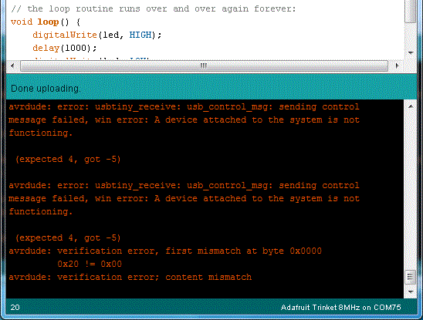](https://learn.adafruit.com/assets/25573)

On Linux if you get the error message "usbtiny_receive: error sending control message: Protocol error (expected 4, got -71)"

These can generally be ignored and should not interfere with the program upload.  Unfortunately Linux's USB core is a little flakey communicating with the ATtiny85 processor on the Trinket/Gemma and can cause these errors.  If an upload does fail, try it again as it is likely an intermittent issue.